Session Diagrams
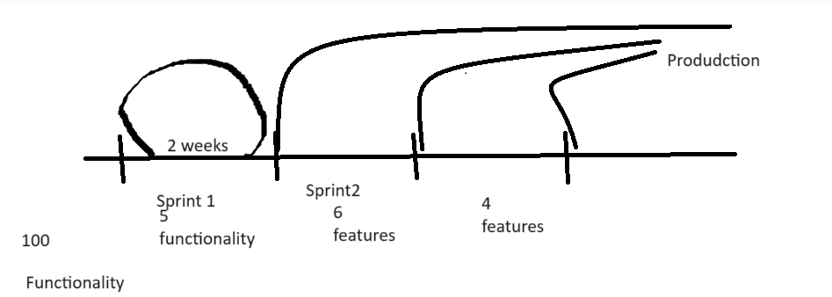
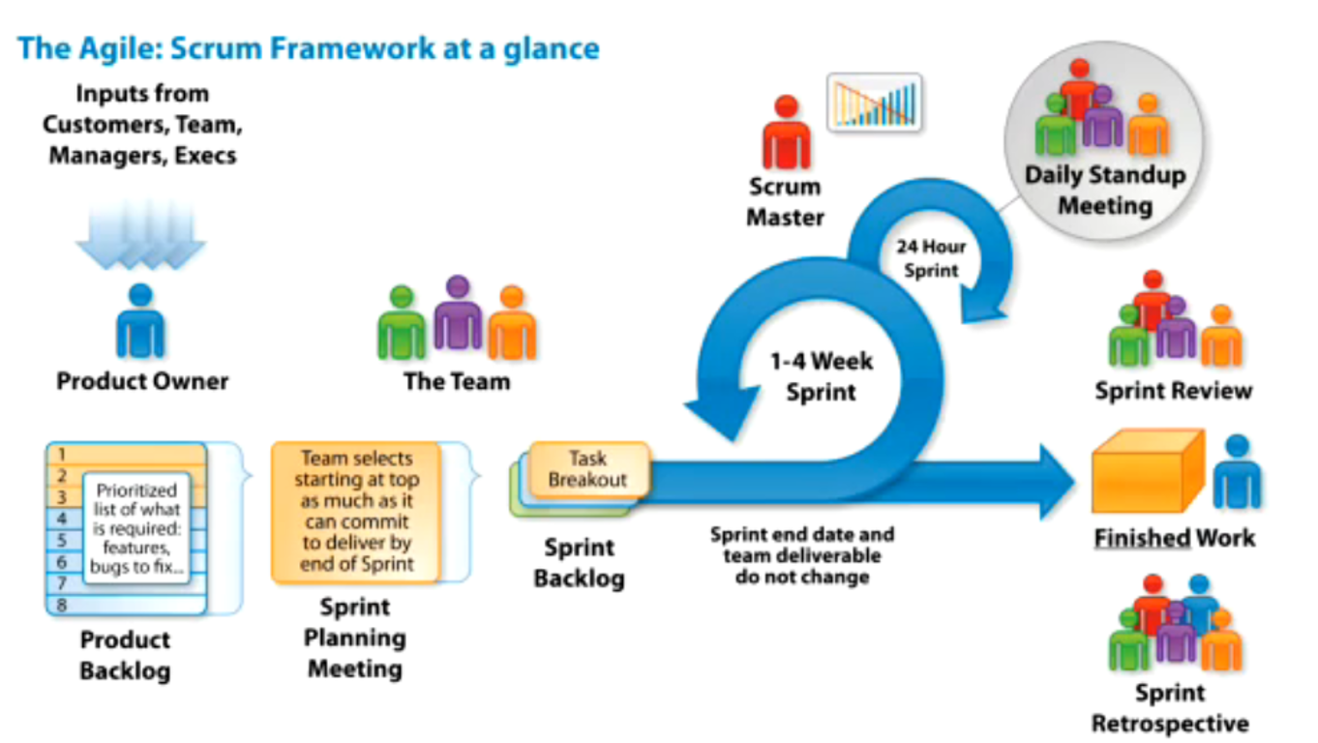

LIVE Notes:

2 months Java internship.

14 year of exp in IT.

Java dev => angular => TechLead(4-5 members)
3-4yrs

=> Engg Manager
10-15
=> Sernior Engg Manager
20-25
=> Head of Technology
40 member team.

More than 1 year..

What problem we are trying to solve..

1440 - INternship.

5 - 10 - 15

99%

hey fresher, get some experience, they we can hire you.
Fresher, give us job then we get exp

2024

learn the ways of IT.
How realtime project deve
what process
tools
design
code as industry standards
test
aws..
working of IT

Anybody can get a chance to do intership.. and learn the ways of IT.

With our Client.. onboard multiple interns.. along with them build the project.

learning experience from this internship..

Value:
1. 2months, working professional having 1-2 years of experience.

2. Functional project.. keeping in your resume & confidently answering all questions during interview.
design, coding, testing, aws, open source, process, functiaon requirements understanding..
Payment System, for our ecommerce client.
LIVE code

Spring & Spring Boot with Microservices.

3. Internship Offer Letter & Internship COmpletion Letter.
Highlight on your linkedin profile, add to resume.. background verification..

4. Currently I am doing Internship and working on so & so project..

====
What technology stack..

HR:
All fresher, should mandatory have project in resume.
Internship exposure..

All the tech / tools / Process
mandatory for freshers to know.
right from 3rd year & 4th year in colleges.. internship is becoming mandatory...

Is mandatory to know..

"3 weeks - 4 weeks", include this project & skills in your resume.. and start doing job hunting..
month2, continue to work in the internship & parallel hunt other job also...

concept + coding knowledge + process + tools..

2 months internship - 8 weeks.
Month1: 4 weeks
Month2: 4 weeks

Week1 & Week2: 10 Days
Core foundation knowledge, needed to work on entire project.

Core Java
+ JDBC
+ Basic Web knowledge(Servlets/Server/Port)

Rest knowledge - training in initial 10days.

Jul - Aug

Sep

Nov

Week3 - Week8

Agile Sprint modal for functional project development.
w3-w4 (Sprint1)
w5-w6 (Sprint2)
w7-w8 (Sprint3)
=========

May Internship... More than 180 members joined for internship...

2hrs session...

Mon-fri, 2hrs (10AM - 12PM)

70 hrs of LIVE internship sessions.

Better than 70% of jobseekrs in the market..

1hr

2 hrs:

10:45AM
1hr, 15mins

Week1
End-to-end working of IT industry
IT process & IT tools

- Include in your resume

You can work, on Realtime project independently

1405 - Listening.

End-to-end working of IT industry
-----------

SDLC - PLC
Start => End???

Client

Tech companies - develop software
- Company develops software for other clients
(Service based)
Products for the client

- Develops projects for themselves.

Product - 10yrs - 15yrs

Product based - service based companies..
Product..

What kind of project you are working upon

Software needs to be developed..
Process of software development SDLC

AGILE - Fare more productive & result oriented

Around 10yrs

Industry way of implementing Agile..

AGILE
"100% Satisfaction for all these people"
- Client
- Software developing company
- Employee
- EndUser/Customer

AGILE -
Time box based iterative approach of software development.
Software is developed incrementally, piece-by-pice. ANd in the end all functionality would be ready..

for/while

2 weeks, 5 features/functionality

Project is in PROD, so only Support work there.. not good developments..

Roles
Development
Support

Java backend API development - Spring Boot & Microservices
Rest Webservice Modual

dev - more money
backend
frontend
support - less
qa-tester - less

for (i = 1; i <= 100; i++) {
1. Requirement gathering & Clarification
2. Designing & Architecting
3. Coding
4. Unit testing
5. Dev env testing - AWS
Code Review
6. QA testing - testers
7. Load/performation testing
8. Security testing
9. UAT testing
10. Production launch
}

remaining 95 features also...

Client gives software requiremetns
tech companies.. gave time lines.. 1yr
After 1yr, give software to customer to use.

2024

2025

1. 100 functionality to be developed.
1yr

Customer / Client - Happy

Agile:

Designations
Meetings
Process

End-to-end project management..

1. what are 100 features?
2. as past of 1st 2 weeks, which features you are working upon?
3. which developer is working on which feature?
4. Currently the features is in what state?
..
..
..
.
Solution will be provided...
process, tool, tech...

Project management Tool: JIRA

Agile + Jira

10 member team.
UI
Java
Testers
Devops
DBA
Tech Leads

1. You would be given access to that Project Jira tool.

Agile can be implemented in multiple ways
1. SCRUM

Product Owner: This person gives requirement.
Client/Business, or tech COmpany
Scrum Master
Team:

1. CLient/Business has project requirement.
2. Product owners will be hired
Client
Tech
3. CLient/Business explains the project requirement to product owners.

4. Product owners give the requirements to Tech Team for development.
Creates requirement In jira. And puts it into Backlog section.
This requiremetns will be given in the form of UserStory
(Enduser - write requirement from perspective of end-user)
Every requirement would be uniquely identified with its ID.

IN jira - Issue
3 types of Issues:
Story (UserStory)
Task
Bug

Ticket
ticketID / userstoryID -

UserStory Format (every requirement should be given in a format) - Agile standardized the format.

As a <User>
I want <what you want>
So that <why you want it>

9Jul, 10AM, continue with the discussion..

Sprint -

Story Point Estimate
Assignee
Due Date
Branching

which person works on which task..
how the sprint is arranged..

70% attendance is mandatory
Daily attendance taking.

Internship Offer Letter
Internship Completion Letter
Free, Paid
------

Week1: FREE for all
All company working process
Tools
COncepts + Practical
Put into your resume.. that any project you do, you apply these concepts.
How to work on real-time industry project without being hired..

Mon-Fri: 10AM - 12PM
8 - 12Jul

Internship Completion Letters for 1000+ is not practical..
With Clients & the IT companies..

Only for PAID members..

Unpaid internship / no stiphend.

70hrs

FREE only for 1 week.

Rest entire system - PAID members..

Thursday - Internship Enrollment (THursday)

More than 180 members have paid enrollment

4lac, 6.. 11lac

1-2 yrs
PRoject
INternship..

Week1: FREE

Week2: PAID member
Week3

Attendance, Tasks, Demos
---------- Filteration

100 REFUND, WILL NOT CONTINUE for rest of INternship.. no Letters offered.

5. Tech Team develops..
...
...
..

Product Backlog (IN jira, represented in Backlog section.)

